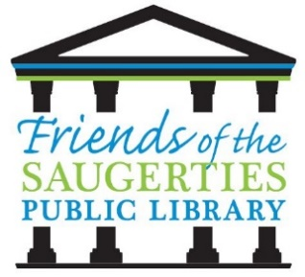
Friends of the Saugerties Public Library

PO Box 1100
Saugerties, New York 12477

2026 SCHOLARSHIP APPLICATION
APPLICATION DEADLINE APRIL 30, 2026
This scholarship in the amount of $1,000 will be awarded to any graduating senior (Saugerties resident) who is eligible to attend a College, University, Trade School, or Certificate program in pursuit of a higher education. The scholarship recipient will be selected based on volunteer service to the school, and/or public library, or the community, as well as a written essay. Service to libraries will be given special consideration.
Applicant’s Name: ________________________________________________________
Address: ________________________________________________________________
Telephone Number: _______________________________________________________
Parent(s)/Guardian(s): _____________________________________________________
1. To be considered for this award, please write an essay (typed and double spaced) explaining why you should be awarded this scholarship. List the extra-curricular activities in which you have participated as a student. Include any leadership and/or community action roles in which you have been involved. Describe your involvement in our community as a volunteer and/or event participant. Describe your activities in support of the local public library or your school library.
2. Please furnish a transcript.
3. Check approximate annual total family income: _____ Under $50,000 _____ Over $50,000
4. Number of brothers and sisters likely to be in college at the same time as applicant: _______
5. What college are you planning to attend and your intended major: _____________________
__________________________________________________________________________
CRITERIA: Continuing Education /Volunteer Services/Involved with School and/or Public Library
AMOUNT OF SCHOLARSHIP: $1,000.00
DEADLINE: April 30, 2026 SUBMIT: To the Senior High Office/Counseling Center

